<https://www.youtube.com/watch?v=_TwpTdrFGlY>

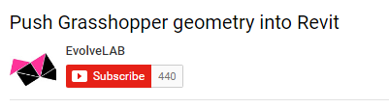

Broad introduction to Rhino and Revit with voice-over that leads into a discussion of integrating Rhino and Revit. The tutorial mentions several tools but focuses on Hummingbird. Narrative includes a lot of basic instruction in Rhino geometry and Revit adaptive components. Also illustrates creating structural elements.

(He says very nice things about Hummingbird! Who is Evolve Lab?)

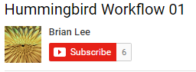

<https://www.youtube.com/watch?v=TRp8MmU6kbI>

Basic tutorial with good voice narrative. Also shows use of “Lunchbox” plug-in with Hummingbird as well as some good techniques for basic Grasshopper.

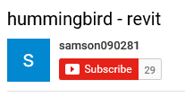

<https://www.youtube.com/watch?v=bS-bLAjq_-M>

A fairly advanced example that does not have any sound track. It illustrates an interesting use of the workflow for a complex building, using adaptive components. Does not have a sound track